UNIVERSAL DE NEGOCIOS Y TURISMO está sujeta al régimen de responsabilidad que establece la Ley 300 de 1996 y los Decretos 1075 de 1997 y 53 de 2002.

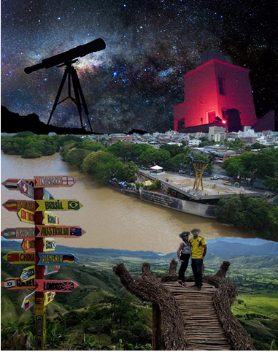

TURISMO EN SANTANDER Y COLOMBIA AGENCIA DE VIAJES MAYORISTA Y OPERADORA UNIVERSAL DE TURISMO
Registro Nacional de Turismo: (12979 RNT)
CONTACTO: 3214494504 – 3102099073 – 3002221614
Dirección: Calle 56 Nro. 34-09, Barrio Sotomayor Bucaramanga - Santander – Colombia
gerenciacomercial@uniturismo.co
www.uniturismo.co

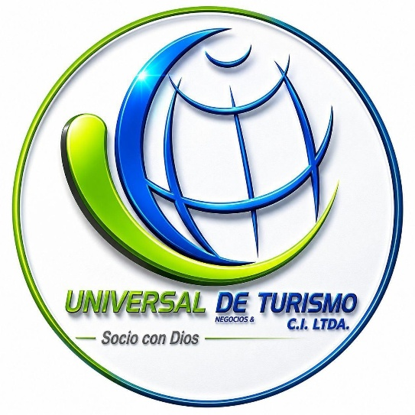

TATACOA DESERT 3D / 2N
NEIVA: TOURISTIC AND CHARMING
We are pleased to present our service portfolio as a Wholesale Tour Operator and Travel Agency (RNT 12979), backed by extensive industry experience and in-depth knowledge of national destinations, including the department of Huila and its top attractions.
We count on a team of trained and certified professionals, along with a comprehensive logistics network across our operating regions, to deliver excellence to our clients and travelers. We specialize in experiential, cultural, heritage, nature, and adventure tourism.
We offer specialized tourist transportation (with full logistical capacity for groups and accessible transport for passengers with reduced mobility), certified professional guides, local field experts, customized tours, horseback riding, eco-trekking, stargazing experiences, adventure sports, natural reserve visits, and hotel and lodge booking management.

NEIVA: TOURISTIC AND LOVING

ATACOA DESERT 3D / 2N
Duration: 3 Days / 2 Nights
Tour Operator: Universal de Turismo (RNT 12979).
- INCLUDED AND NOT INCLUDED SERVICES
THE PACKAGE INCLUDES:
- Private special tourist transportation throughout the entire itinerary (sized according to group size).
- Airport / Bus Station transfer in & out (meet and greet + hotel transfers) and transport to all program destinations.
- Travel medical insurance policy (Colasistencia with COVID-19 coverage).
• Accommodation & Meals:
- 3 Days / 2 Nights accommodation at the selected hotel (double occupancy minimum).
- Meals: 2 Breakfasts (1 per night of stay).
• Tours & Included Experiences:
- Neiva City Tour: Historical, cultural, and culinary tour + Motorboat ride along the Magdalena River.
- Ecotourism & Thermal Springs: Visit to Rivera Thermal Springs (Termales de San Francisco).
- Tatacoa Desert: Colonial Route, Paleontological and Totumo Museums, El Cuzco Hiking Trail (Red Zone) and Los Hoyos Trail (Grey Zone), viewpoints, natural desert swimming pool, and Stargazing Talk with high-end telescopes.
- Mountain Route: Tour to La Mano del Gigante viewpoint and cultural tour of Gigante municipality.
• Guiding Services:
- Specialized local tour guides .

The Package Does Not Include:
- Meals not specified in the itinerary (Lunches and Dinners).
- Additional tours or activities not described in the itinerary.
- Bilingual guide service (Available upon request at an extra cost).

DETAILED DAY-BY-DAY ITINERARY

DAY 1: Charming Neiva, Magdalena River & Rivera Thermal Springs
- Morning / Midday:
  - Meet & greet at Benito Salas Airport or Neiva Bus Station. Transfer and check-in at selected hotel.
  - Historical & Cultural Neiva City Tour: A 17 km tour discovering 20 heritage sites and iconic monuments (La Raza y el Mestizaje, Me Llevarás en Ti, La Lavandera, Llamarada, Los Guaduales, El Caracolí, La Gaitana, Madre Tierra, Domo de las Antípodas, Al Sur, Luna Roja, and Tambores de Pacandé).
- Afternoon:
  - Magdalena River Boat Tour: Navigation aboard traditional outboard motor canoes departing from Neiva’s Boardwalk (Malecón). Wildlife watching (herons, woodpeckers, blue tanagers, hummingbirds) and visits to attractions like Mohán's Cave, Isla Park, San Agustín replicas, Santander Bridge, and the river mouths of Las Ceibas and Del Oro rivers.
  - Relaxation at Rivera Thermal Springs: Transfer to El Salado rural area in Rivera (Termales de San Francisco). Soaking time in mineral-rich thermal pools at temperatures ranging from 35 °C to 41 °C (95 °F to 106 °F).
- Evening:
  - Return to hotel in Neiva and rest.

DAY 2: Exotic & Star-Filled Tatacoa Desert
- Morning:
  - Breakfast at hotel.
  - Departure to Villavieja.
  - Colonial & Cultural Route: Guided tour of the main square, chapel, visit to the Paleontological Museum, and craft cactus beer house.
  - El Cuzco Ecotourism Hike (Red Zone): Scenic view and visit to El Cuzco and El Cardón viewpoints. Guided hike through the prehistoric "fossil graveyard" (giant ground sloths and purussaurus), exploring El Estrecho del Cuzco, Estoraque Mayor ("Testigo del Suelo"), La Catedral, Cárcavas, Cueva del Chulo, El Ojo del Desierto, and El Árbol del Amor.
- Afternoon:
  - Los Hoyos Ecotourism Hike (Grey Zone): Scenic loop through Ventanas, Puerta Sideral, Zoológico de Arena, and Valle de los Deseos. Deep exploration of the grey zone (Los Altares, Valle de los Fantasmas, Torres Gemelas, and Salto del Manantial rock formations).
  - Desert Relaxation: Free time for a refreshing swim in the natural desert pool.
- Evening:
  - Stargazing Experience: Astronomical talk and sky map orientation led by astronomer Javier Fernando Rúa Restrepo at the Astronomical Observatory. Observation of the Milky Way, constellations, the Moon, and planets using high-end telescopes.
  - Return to Neiva and rest at the hotel.
PAX | CAMPING (DESIERTO) | POSADA TURÍSTICA (DESIERTO) | SUEÑO REAL (VILLAVIEJA) | YARARAKA (VILLAVIEJA) | OASIS DEL DESIERTO (VILLAVIEJA) | HOSTAL (VILLAVIEJA)
2 | USD $245.16 | USD $260.06 | USD $307.38 | USD $296.20 | USD $288.75 | USD $277.57
3 | USD $237.71 | USD $252.61 | USD $296.20 | USD $281.30 | USD $277.57 | USD $266.39
4 | USD $230.25 | USD $241.43 | USD $285.02 | USD $270.12 | USD $266.39 | USD $258.94
5 | USD $219.08 | USD $233.98 | USD $277.57 | USD $258.94 | USD $258.94 | USD $247.77
6 | USD $211.63 | USD $222.80 | USD $270.12 | USD $251.49 | USD $251.49 | USD $240.31
7 | USD $204.17 | USD $215.35 | USD $258.94 | USD $244.04 | USD $244.04 | USD $232.86
8 | USD $196.72 | USD $207.90 | USD $247.77 | USD $236.59 | USD $236.59 | USD $225.41
9 | USD $189.27 | USD $200.45 | USD $240.31 | USD $229.14 | USD $229.14 | USD $217.96

GENERAL TERMS & CONDITIONS
- Accommodation: Rates quoted per person based on double occupancy or higher. Does not apply to single occupancy.
- Availability: Rates subject to hotel availability and changes without prior notice until the reservation is officially confirmed.
- Non-refundable Services: Unused services, tours, or activities due to the traveler's own decision are non-refundable.

CANCELLATION & PENALTY POLICY
Definite cancellations with full refunds are not accepted. In the event of withdrawal or cancellation, the following penalties will apply based on the total value of the plan and the notice period provided:
- 15 days or more in advance: 20% penalty of the total cost.
- 14 to 8 days in advance: 30% penalty of the total cost.
- 7 to 4 days in advance: 40% penalty of the total cost.
- 3 to 2 days in advance: 60% penalty of the total cost.
- 24 hours or No-Show: 100% penalty of the total cost.

