SANTA MARTA & EL RODADERO GETAWAY
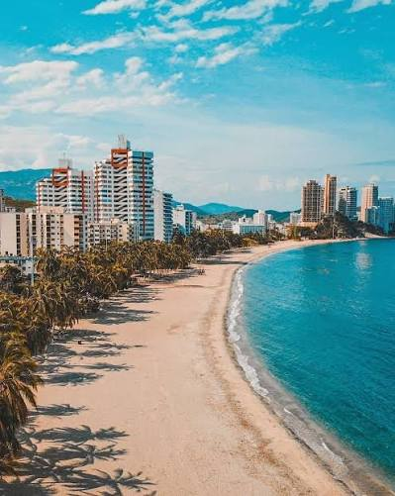
Get ready to relax on Colombia’s Caribbean coast! Enjoy stunning beaches, great food, and the unique spot where the river meets the sea.
📅 Upcoming Departure Dates OPEN:
- August 20th – 23rd, 2026
- August 27th – 30th, 2026
📍 Meeting ONLY Point: Parque Corona at 6:30 PM
⏱️ Duration: 3 Days / 2 Nights
¿What’s Included in Your Trip?
- 🚌 Comfortable Transport(AAA): Round-trip travel in a fully equipped tourist bus.
- 🏨 Stay in El Rodadero: 2 nights in a cozy hotel with air-conditioned rooms and a swimming pool.
- 🍽️ All-Inclusive Meals: 3 breakfasts, 3 lunches, and 3 dinners (plus a welcome snack on departure night).
- 🚤 Unforgettable Day Trips:
  - Buritaca Beach: Experience the amazing junction where the river meets the ocean (Includes breakfast & lunch).
  - Playa Blanca: Scenic boat ride to crystal-clear waters (Includes lunch).
  - El Rodadero Beach: Free time to explore, shop, and soak up the local vibes.
- Peace of Mind: Full medical insurance and a dedicated trip coordinator to assist you every step of the way.
👥 Room Options & Rates:
- Double and multiple occupancy available.
- Special rates for children 5 years and older.

PRICES
HOTEL WITH POOL | MULTIPLE | DOUBLE | KIDS 5 – 10 YEARS | S
OLAS MARINAS RODADERO | $204 | $210 | $194 | 17
SAN FRANCISCO | $216 | $223 | $200 | 17
OLAS INN | $204 | $213 | $181 | 17

HOTEL OLAS MARINAS RODADERO
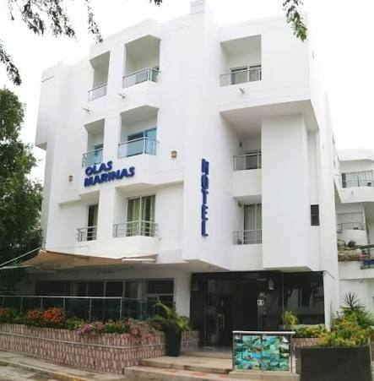

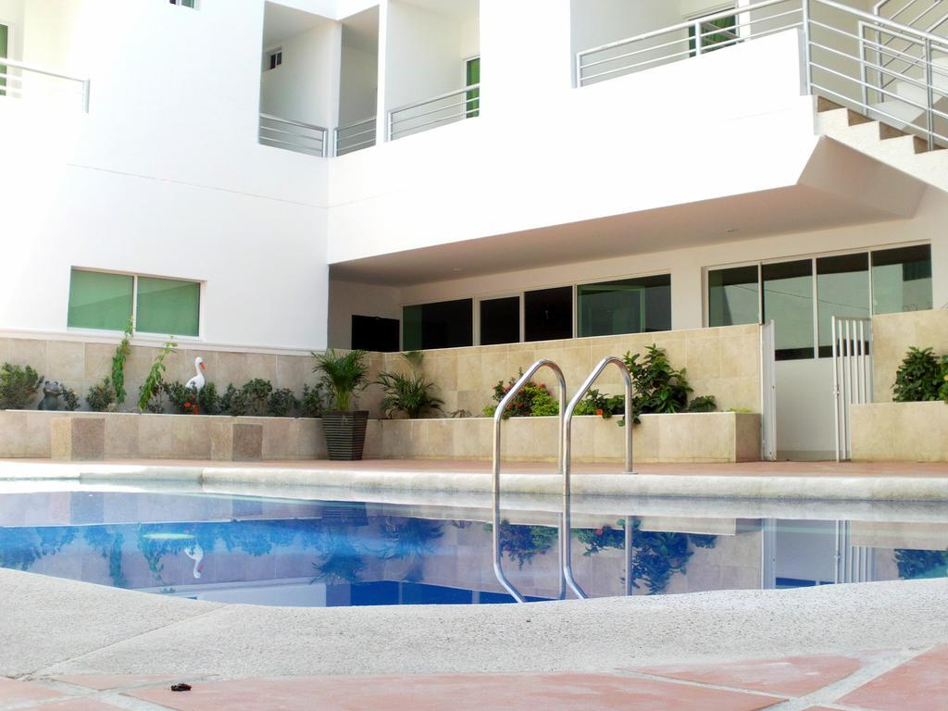
POOL

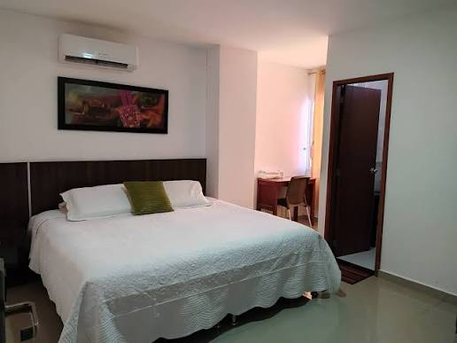
DOUBLE TWIN

