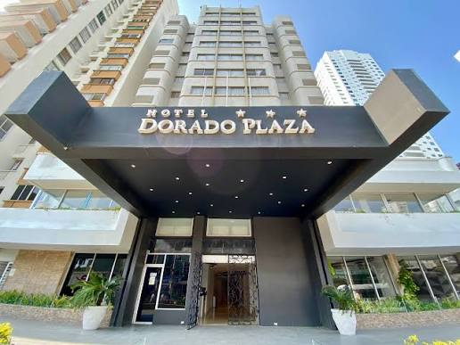

HOTEL CARTAGENA GOLDEN FULL STYLE
Hotel in Front of Bocagrande Beach Equipped with a swimming pool for children and adults, restaurant, nightclub, and bar.
Dates:
- October 1-4, 2026
- October 15-18, 2026
- October 22-25, 2026
Stay: 3 Days / 2 Nights
Departure Time: 4:00 AM – Corona Park

The Package Includes:
- Air-conditioned tour transport.
- 3 Days / 2 Nights accommodation at Hotel Dorado Plaza (Standard Rooms - Full Style).
- Full board meal plan (unlimited buffet style):
  - Breakfast (Buffet): 7:00 AM – 10:00 AM
  - Lunch (Buffet): 12:00 PM – 2:00 PM
  - Dinner (Buffet): 7:00 PM – 9:00 PM
  - Snacks: 11:00 AM – 12:00 PM / 4:00 PM – 5:00 PM / 10:00 PM – 10:30 PM
- 24-hour open bar with domestic spirits, cocktails, soft drinks, and beer.
- Day trip to Barú (Includes breakfast and lunch).
- Travel medical assistance.
- Live evening shows.
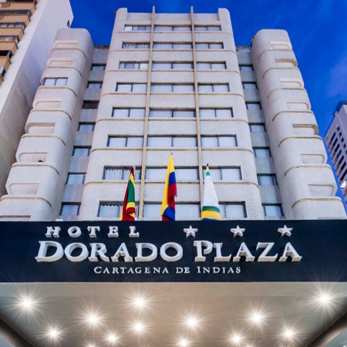
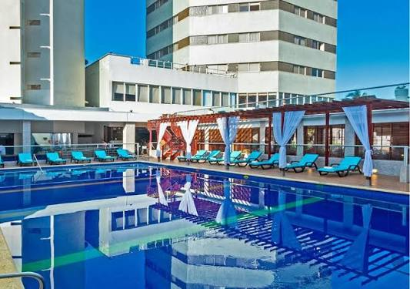
- Supervised recreational activities for adults and children.

HOTEL CARTAGENA GOLDEN FULL STYLE | PRICES FOR PERSON ($USD) | Children (Ages 6 to 10) | Children under 4 years old
MULTIPLE/DOUBLE | $290 | $259 | 20
• Children aged 0 to 3: Pay $20 USD for medical insurance. Other services are shared with accompanying adults.
• 4-year-old children: The package costs $160 USD and includes transportation, medical insurance, and snacks.

• Niños de 0 a 3 años: Pagan $60.000 COP correspondiente a la asistencia médica. Los demás servicios los comparten con los adultos.
• Niños de 4 años: El plan cuesta $500.000 COP e incluye transporte, asistencia médica y refrigerio

