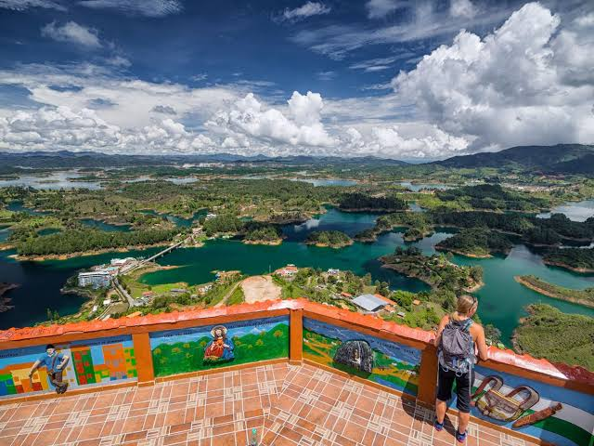

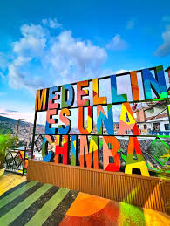
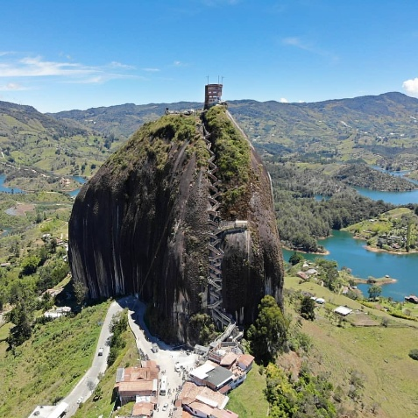
3-in-1 Paisa Experience: Guatapé, Hacienda Nápoles & Medellín Comuna 13
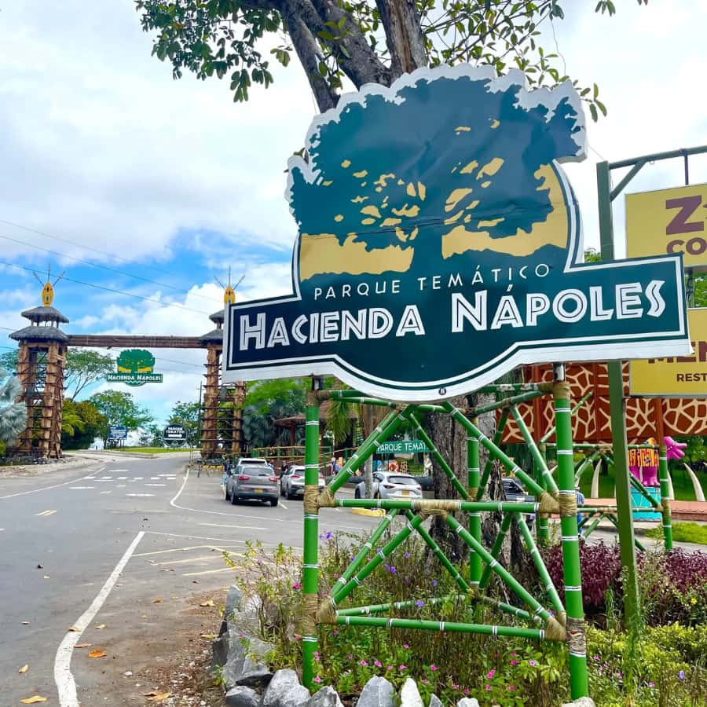

Trip Itinerary: 3 Days / 2 Nights
- Departure Dates: September 3–6, 2026 | September 17–20, 2026
- Departure Time: 11:00 PM
- Meeting Point: Puerta del Sol(BGA, SANTANDER. COL)
INCLUDED IN THE PLAN
- Air-conditioned tourist transportation
- Guided visits to all attractions mentioned in the itinerary
- Hotel accommodation (2 nights / 3 days)
- Meals: 3 breakfasts and 3 lunches
- Medical assistance card
- Boat tour on the Guatapé Reservoir
- Guided tour of Comuna 13
- Entrance ticket to Hacienda Nápoles Theme Park
- Tour guide throughout the trip
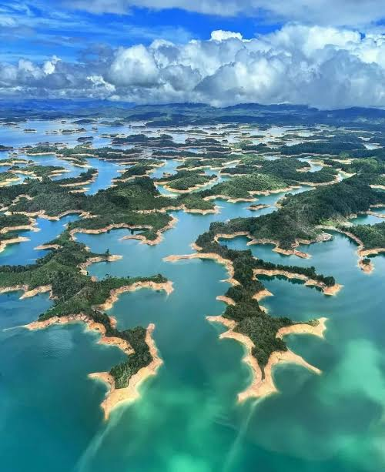

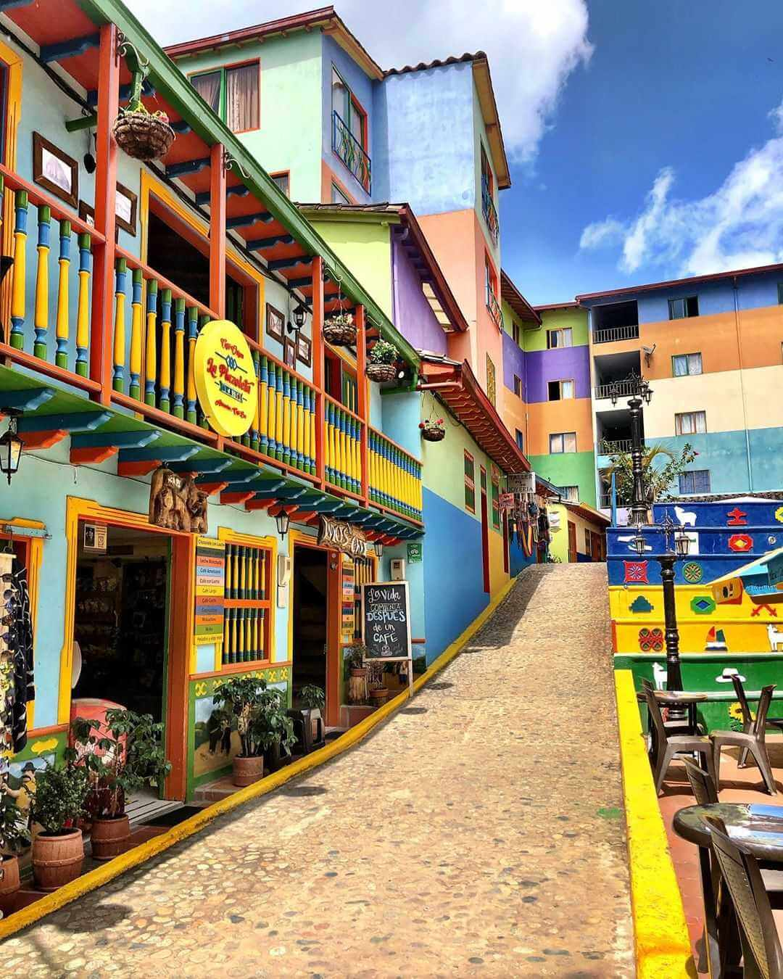

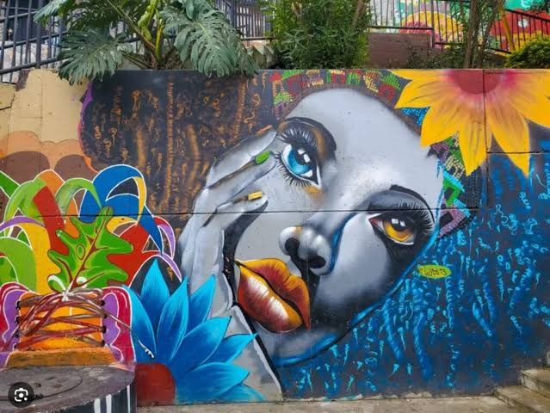
ITINERARY ATTRACTIONS & ACTIVITIES
- El Peñol Rock (Piedra del Peñol): Visit to the iconic monolith (entrance fee not included)
- Guatapé Reservoir: Boat cruise across the lake
- Medellín Public Transit: Metro and Metro Cable rides
- Parque de los Pies Descalzos: Interactive barefoot park
- Nutibara Hill (Cerro Nutibara): Tour of Pueblito Paisa and shopping area
- The Colombian Santorini (Doradal): Sightseeing walk through the Mediterranean-style village
- Hacienda Nápoles Attractions:
  - Jurassic Adventure (Aventura Jurásica)
  - Biolandia & Wildlife Sanctuary
  - African Museum & Hippotamus Park
  - Reptile World, Bird World, and Butterfly House
  - Octopus Water Zone, Cobra Water Slide, Wild Rivers, and Victoria Falls
  - Pangea World
- Comuna 13: Graffiti and urban art tour

HOTEL | MULTIPLE | DOBLE | NIÑOS 5 -9AÑOS | NIÑO 0 A 3 AÑOS SEGURO
 | $USD235 | $USD245 | $USD236 | $16

➢ NIÑOS 0- 2 AÑOS CANCELAN –ASISTENCIA MEDICA-$USD16
➢ NIÑOS 3 – 5 AÑOS CANCELAS TRASNPORTE – ASISTENCIA MEDICA – METRO CABLE Y CABLE METRO ENTRADA NAPOLES $USD186
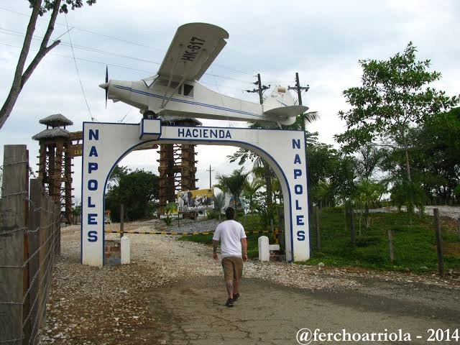


➢ NIÑOS DE 5 – 9 AÑOS PLAN COMPLETO $ USD235

