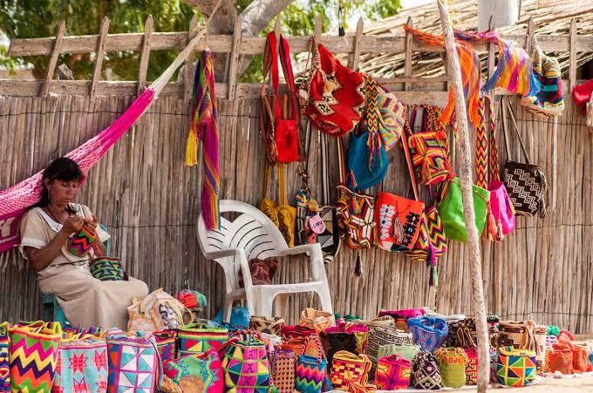
EXOTIC, MAGICAL GUAJIRA & CABO DE LA VELA CULTURE
DEPARTURE: SEPTEMBER 16–20, 2026 / 4 DAYS 3 NIGHTS

PLACES WE WILL VISIT:
- Camarones Beach and afternoon at a Wayuu Ranchería.
- Day trip to Cabo de la Vela and Pilón de Azúcar.
- Mayapo Beach and photo stop at Riohacha Boardwalk.
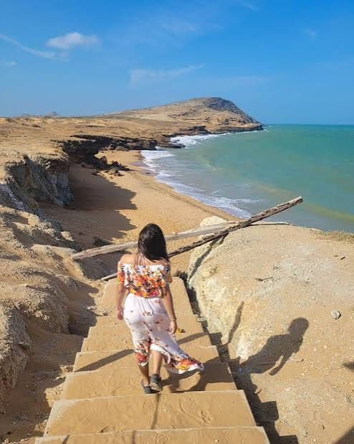
- Valledupar: "Ruta del Cacique" tour (Ventana Marroncita, La Junta) and swim at Guatapurí River.

PACKAGE INCLUDES:
- Air-conditioned tour bus transport.
- Varied daily meals.
- 4 breakfasts, 4 lunches, and 3 dinners.
- Medical assistance – Wayuu Ranchería entry.
- 3 nights hotel accommodation in Riohacha.
- Evening snack on departure night.
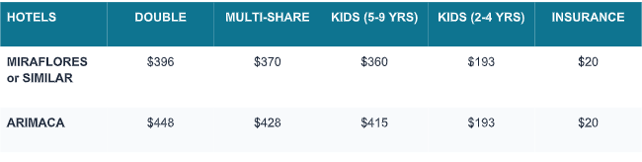
- Tour leader / group tourist guide.

CHILD POLICIES &amp; NOTES
• Children 0 to 2 years old: Pay $20 USD for personal medical assistance card.
• Children 5 to 9 years old: Includes full tour package ($360 USD at Hotel Miraflores / $415 USD at Hotel
Arimaca).
• Children 2 to 4 years old: Pay $193 USD (includes transport and medical assistance; other services are shared
with parents).

