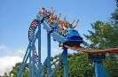

EJE CAFETERO 3N/4D
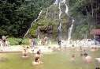

DEPARTURE: SEPTEMBER 16–20, 2026
DEPARTURE TIME: 4:00 PM – PARQUE CORONA
PLAN: 4 DAYS / 3 NIGHTS

SERVICES INCLUDED:
- Round-trip fully equipped transport.
- Accommodation for 4 days / 3 nights at a Hotel Farm with a swimming pool, rooms with private bathroom and TV, restaurant service, pool, green areas, and comfortable rooms.
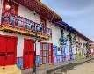
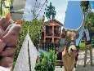
- Meal plan: 4 breakfasts, 4 lunches, 3 dinners.
- Medical assistance.
- Visits to all mentioned locations.
- Tour leader / group guide.

ITINERARY:
- Santa Rosa de Cabal: Thermal bath pools.
- Montenegro: Coffee Park (Parque del Café) with all attractions included (Multiple Passport).
- RECUCA: Interactive Coffee Culture Tour.
- Salento: Artisanal town (Cocora Valley optional).
- Filandia: Colorful town visit.

RATE OF PLAN | DOUBLE | MULTIPLE | CHILDRENS 4 - 5 YEARS | CHILDRENS UNDER O A 3 YEARS SEGURITY
 | $ 323 | $ 313 | $ 222 | $ 20
POLICIES FOR CHILDREN:
• Children 0–3 years: Pay $60,000 for the medical assistance card.
• Children 4–5 years: Pay $680,000 (includes transport, medical assistance, park entrance fees, accommodation, and shared meals with parents.
