**ZAPATOCA “SILK WEATHER” 1N/2D**

¡AN AMAZING PLACE!

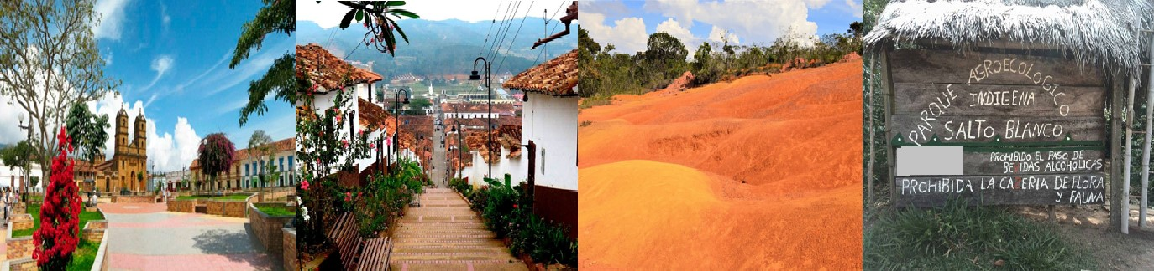

**PLAN INCLUDES**

* Hotel accommodation (1 night).
* Taxes and hotel insurance,
* Medical assistance
* Transportation Bucaramanga-Zapatoca-Betulia-Bucaramanga.
* Meals: Breakfast, Lunch, Dinner
* Admission to the Cosmos Museum
* Admission to the Nitro Cave
* Admission and tasting at the Sierra Morena Organic Winery.
* Visit to the tomb of Geo Von Lenguerke
* Visit to Guane-viewpoint
* Visit to Betulia, the white girl of Santander.
* Visit and admission to the El Salto Blanco Agro-ecological Park
* Visit to the Guane Cemetery
* Tour guide to provide guidance during the visits

|  |  |
| --- | --- |
| **RATE PER PERSON** | |
| **DOUBLE ACCOMMODATION** | **MULTIPLE ACCOMMODATION** |
| **$153** | **$137** |