**FLY AND IMMERSE YOURSELF IN CHARALÁ 2N/3D**

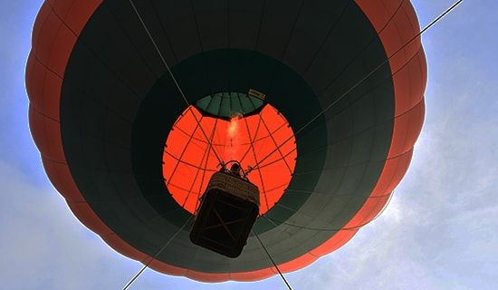

**PLAN INCLUDES:**

* 2 nights' accommodation.
* Breakfasts.
* Lunches
* Dinner.
* 4 snacks.
* Medical assistance insurance (COLASISTENCIA).

**ACTIVITIES**

* Ecological trail, landscaping, and canyoning.
* Visit to 5 natural wells.
* Enjoy 4 waterfalls.
* Rappelling in a 20-meter waterfall.
* Logistics, inflation, and captive flight in a hot air balloon.
* Ecological Trail: Native forests, demonstration livestock farm (pastures, hedgerows).
* Swimming in a natural pool on the Taquiza and Neugatas Rivers or tubing (floating down the river on a tire).
* Tour of the historic and cultural center of Charalá.

**NOT INCLUDED**

* Expenses not specified in the program
* Does not include transportation to the municipality of Charalá.

|  |
| --- |
| **RATE PER PERSON** |
| **Triple Accommodation:** |
| **$198 dollars** |
|
|

**ITINERARY**

Departure time: 8:00 AM

Meeting point: Calle 25 - 11-46 Neighborhood Comuneros, Municipality of Charalá. A few steps ahead of the Anexa School

**DAY 1**

* Reception and drop off luggage at the agency.
* Breakfast, reception, and logistics.
* Transfer by vehicle to: Ecological Trail, landscaping, and canyoning.
* Visit to 5 natural wells.
* Traditional snack.
* Enjoy 4 waterfalls.
* Abseiling with water or canyoning in a 20-meter waterfall.
* Check-in at the hotel.
* Free afternoon.
* Dinner and integration activities.

**DAY 2**

* The day begins at 5:00 a.m. - 5:30 a.m. Pick-up at the hotel.
* 5:30 a.m. - 6:00 a.m. Logistics: Inflation, trimming, anchoring, and lifting the balloon for the first time. (Height 100 meters, each flight carries 3 people, average total weight 180 - 190 kilos, flight duration 7 minutes).
* 8:30 a.m. Breakfast.
* 9:30 a.m. Start of activities.
* 20-minute transfer to:
* Ecological Trail: Native forests, demonstration cattle farm (pastures, hedgerows).
* Swim in the natural pool in the Taquiza River and Neugatas or tubing (floating down the river on a tire).
* Lunch in the historic center.
* Walk through the historic and cultural center of Charalá.
* End of activity.

**TRAVEL EQUIPMENT FOR ACTIVITIES:**

* Eco-friendly sunscreen and insect repellent.
* Personal towel for use during hikes.
* Small backpack for use during hikes.
* Travel clothing
* Sneakers or lace-up shoes.
* Shorts
* Sweatshirt or long-sleeved shirt.
* Hat or cap.
* Personal first aid kit for allergies or special medications.

**IMPORTANT:**

* All participants in the scheduled activities do so of their own free will and are responsible for their actions.
* All departures are from Chárala.