**VISITING SANTANDER 3N/4D**

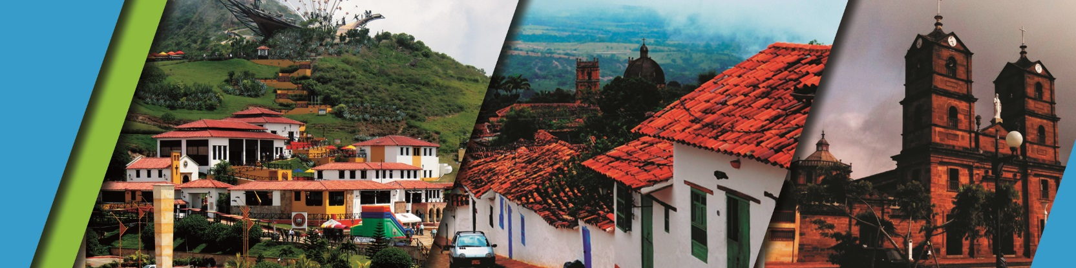

We invite you to discover Bucaramanga and Santander with the best plan:

**PLAN INCLUDES:**

* Accommodation at the hotel in Bucaramanga (3 nights)
* Taxes and Hotel Insurance
* Airport – Hotel – Airport Transfer
* Chicamocha National Park Transfer -
* Accommodation in San Gil or Barichara
* Breakfasts at the Hotel
* Dinners
* Lunches
* City Night Tour – Cerro Del Santísimo (shared outing)
* Tour Crossing the Chicamocha (shared outing)
* San Gil Tour (shared outing)
* Curití Tour (shared outing)
* Barichara Tour (shared outing)
* Medical assistance

**NOT INCLUDED**

* Expenses not specified in the program

**ITINERARY**

**Day 1**

* Transfer Airport/Terminal – Hotel
* City Night Tour (Permanent Transportation, Tour Guide, Travel Insurance)
* Visit to Girón (Heritage Town)
* Visit to Floridablanca, oblea Tasting, Entrance to Eco park, Cable Car Ride to Cerro El Santísimo, visit to the longest Cable-Stayed Bridge in Bucaramanga)
* Dinner
* Accommodation in Bucaramanga

**Day 2**

* Breakfast at the hotel
* Tour Crossing the Chicamocha canyon (Departure: 7:45 am Lobby del Hotel, visit to the Farmer’s Market at Mesa de los Santos, Snack - Entrance to PANACHI (Chicamocha National Park) by “Plazuela station”, Cable Car ride (6.3 km) where you can observe the wonderful canyon, a complete tour of the park facilities, admission to the water park, and a typical regional lunch.
* Return to Bucaramanga
* Dinner
* Accommodation in Bucaramanga

**Day 3**

* Breakfast at the hotel
* Visit and tour of Curiti
* Visit and admission to EL GALLINERAL NATURAL PARK
* Transfer to BARICHARA
* Lunch
* Visit to Barichara and surrounded areas
* Dinner
* Accommodation in Bucaramanga

**Day 4**

* Breakfast at the Hotel
* Day off (optional City tour $27 per person)
* Hotel-Airport transfer

|  |  |  |  |  |
| --- | --- | --- | --- | --- |
| **RATES PER PERSON** | | | | |
| **HOTEL** | **MULTIPLE** | **DOUBLE** | **SINGLE** | **CHILDREN (5 a 10 years old)** |
| **TOURIST** | $261 | $329 | $487 | $219 |
| **SUPERIOR** | $332 | $366 | $527 | $253 |
| **LUXURY SUPERIOR** | $361 | $440 | $695 | $326 |

|  |  |  |
| --- | --- | --- |
| **CHILD RATE** | | |
| **AGE** | **PRICE** | **INCLUDE** |
| **0 a 2** | $ 5 | Medical Assistance |
| **3 a 4** | $ 45 | Medical assistance, attraction tickets, and transportation |

* Dinner with a glass of wine applies to accommodation in the SUPERIOR AND SUPERIOR DELUXE categories.

*All services additional to accommodation will be operated directly by the agency.

*Exclusive transportation supplement for 1-4 people. $800.000*

* When the Visiting Santander Plan coincides with a long weekend, it is confirmed with all nights in Bucaramanga.

*All departures are regular (excursion type).*

**\*Child rate NOT commissionable\***

**RECOMMENDATIONS DURING THE TOUR**

To ensure you enjoy your experience to the fullest on this tour, we would like to share the following recommendations with you:

* Bring sunscreen
* Bring a cap or hat
* Bring cool clothing and comfortable shoes
* Bring a swimsuit to enter the water park
* Bring a change of clothes for after cannoning (additional cost)
* Driver's license to enter the buggies (additional cost)
* Bring a camera
* Bring water
* To help preserve the environment, we recommend disposing of waste in a trash can.

**HOTELS**

