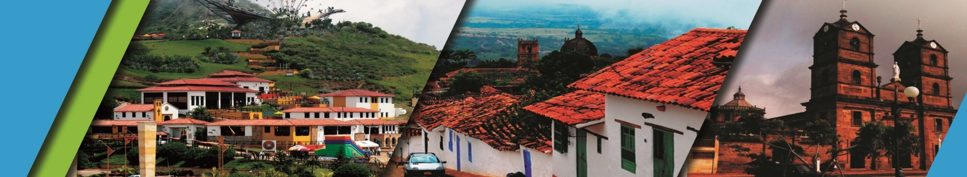**TRAVELING SANTANDER 5N/6D**

**TRAVELING BY SANTANDER 5N/6D**

We invite you to discover Bucaramanga and Santander with the best plan:

**PLAN INCLUDES:**

* Accommodation in Bucaramanga (5 nights)
* Taxes and hotel insurance
* Airport – Hotel – Airport transfer
* Breakfasts, Dinners, Lunches
* City Night Tour – Cerro El Santísimo (regular departure- Park closed on Mondays)
* Tour Crossing Chicamocha Canyon (regular departure- Park closed on Mondays and Tuesday)
* Tour San Gil, Tour Barichara, Tour Curití (shared outing)
* City tour Bucaramanga and shopping (shared outing)
* Tour Zapatoca (shared outing)
* Medical Assistance

**NOT INCLUDED:**

* Expenses not specified in the plan

**ITINERARY**

**Day 1**

* Transfer Airport/Terminal – Hotel
* City Night Tour (Meeting point - Hotel Lobby, Permanent Transportation, Tour Guide, Travel Insurance
* Visit to Girón (Heritage Town)
* Visit to Floridablanca, oblea Tasting, Entrance to Eco park, Cable Car Ride to Cerro El Santísimo, visit to the longest Cable-Stayed Bridge in Bucaramanga)
* Dinner
* Accommodation in Bucaramanga

**Day 2**

* Breakfast at the hotel
* Tour Crossing the Chicamocha canyon (7:45 a.m at the Hotel lobby, visit to the Farmer’s Market at Mesa de los Santos, Snack - Entrance to PANACHI (Chicamocha National Park) by “Plazuela station”, Cable Car ride (6.3 km) where you can observe the wonderful canyon, a complete tour of the park facilities, admission to the water park, and a typical regional lunch.
* Return to Bucaramanga
* Dinner
* Accommodation in Bucaramanga.

**Day 3**

* Breakfast
* Visit to CURITI (weaver town)
* Visit and entrance at Natural Park EL GALLINERAL
* Transfer to BARICHARA
* Lunch
* Tour the most beautiful town in Colombia BARICHARA and its churches
* Dinner
* Accommodation in Bucaramanga

**Day 4**

* Breakfast
* Crossing “GÓMEZ ORTIZ” bridge (500 mts) above Hidrosogamoso Dam
* Tour around Zapatoca - ´´the silk weather town´´
* Visit to SAN JOAQUÍN Church
* Entrance at "CASA DE EJERCICIOS"
* Lunch
* Visit to “MIRADOR GUANE” (viewpoint)
* Visit to “CUEVA DEL NITRO” (cavern)
* Dinner
* Accommodation in Bucaramanga

**Day 5**

* Breakfast
* City Tour (Departure: Historical tour of the Beautiful City, entrance to the Sagrada Familia Cathedral, visit to the city's first park, Custodio García Rovira Park, panoramic tour of the government buildings, City Hall, and Palace of Justice. This historical tour ends in San Francisco, the famous shoe district.
* Lunch
* Dinner
* Accomodation in Bucaramanga

**Day 6**

* Breakfast
* Day off

|  |  |  |  |  |
| --- | --- | --- | --- | --- |
| **RATE PER PERSON** | | | | |
| **HOTEL** | **MULTIPLE** | **DOUBLE** | **SIGLE** | **CHILDREN (5 a 10)** |
| **TOURIST** | $382 | $474 | $658 | $ 287 |
| **SUPERIOR** | $434 | $524 | $711 | $355 |
| **LUXURY SUPERIOR** | $500 | $611 | $868 | $434 |

|  |  |  |
| --- | --- | --- |
| **CHILDREN RATE** | | |
| **AGE** | **PRICE** | **INCLUDE** |
| **0 a 2** | $ 10 | Medical Assistance |
| **3 a 4** | $ 61 | Medical assistance, attraction tickets, and transportation |
|  |  |  |

*Dinner with a glass of wine applies to SUPERIOR and SUPERIOR DELUXE accommodations*

*Exclusive transportation supplement for 1-4 people: $1,300,000*

*All departures are regular (excursion type) * *All services additional to accommodation will be operated directly by the agency. * *Children rate is NOT commissionable*

**RECOMMENDATIONS DURING THE TOUR**

To ensure you enjoy your experience to the fullest on this tour, we share the following recommendations:

* Bring sunscreen
* Bring a cap or hat
* Wear cool clothing and comfortable shoes
* Bring a swimsuit to enter the water park
* Bring a change of clothes for after the rappel (additional cost).
* Driver's license to ride in the buggies (additional cost).
* Camera.
* Bring wáter
* To help preserve the environment, we recommend disposing of trash in a trash can.

**HOTELS**

