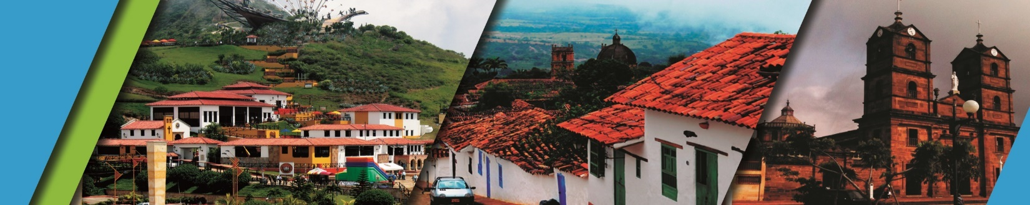

**TOWNSHIPS IN SANTANDER 4N/5D**

We invite you to discover Bucaramanga and Santander with the best plan:

**PLAN INCLUDES:**

* Accommodation at the hotel in Bucaramanga (4 nights)
* Taxes and Hotel Insurance
* Airport – Hotel – Airport Transfer
* Breakfasts
* Dinners
* Lunches
* City Night Tour – Park Cerro El Santísimo
* Tour Crossing The Chicamocha Canyon
* Tour to San Gil, Barichara and Curití
* Tour to Zapatoca
* Medical assistance

**NOT INCLUDED**

* Expenses not specified in the program.

**ITINERARY**

**Day 1**

* Transfer Airport/Terminal – Hotel
* City Night Tour (Departure: 3:30 pm Hotel Lobby, Permanent Transportation, Tour Guide, Travel Insurance
* Visit to Girón (Heritage Town)
* Visit to Floridablanca, oblea Tasting, Entrance to Eco park, Cable Car Ride to Cerro El Santísimo, visit to the longest Cable-Stayed Bridge in Bucaramanga)
* Dinner
* Accommodation in Bucaramanga

**Day 2**

* Breakfast at the hotel
* Tour Crossing the Chicamocha canyon (Departure: 7:45 am Lobby del Hotel, visit to the Farmer’s Market at Mesa de los Santos, Snack - Entrance to PANACHI (Chicamocha National Park) by “Plazuela station”, Cable Car ride (6.3 km) where you can observe the wonderful canyon, a complete tour of the park facilities, admission to the water park, and a typical regional lunch.
* Return to Bucaramanga
* Dinner
* Accommodation in Bucaramanga.

**Day 3**

* Breakfast at the Hotel
* Visit to CURITI (weaver town)
* Visit and entrance at NATURAL PARK EL GALLINERAL
* Transfer to Barichara (Most beautiful town in Colombia)
* Lunch
* Tour around BARICHARA
* Dinner
* Accommodation in Bucaramanga

**Day 4**

* Breakfast
* Crossing “GÓMEZ ORTIZ” bridge (500 mts) above Hidrosogamoso Dam
* Tour around Zapatoca ´´The silk weather town´´
* Visit to SAN JOAQUÍN Church
* Entrance at "CASA DE EJERCICIOS"
* Lunch
* Visit to “MIRADOR GUANE” (viewpoint)
* Visit to “CUEVA DEL NITRO” (cavern)
* Dinner
* Accommodation in Bucaramanga

**Day 5**

* Breakfast
* Day off (Optional City Tour or Shopping Tour $27 per person)
* Hotel-Airport transfer

|  |  |  |  |  |
| --- | --- | --- | --- | --- |
| **RATES PER PERSON** | | | | |
| **HOTEL** | **MULTIPLE** | **DOUBLE** | **SINGLE** | **CHILDREN (5 a 10 years old)** |
| **TOURIST** | $342 | $408 | $587 | $287 |
| **SUPERIOR** | $382 | $445 | $618 | $331 |
| **LUXURY SUPERIOR** | $489 | $524 | $737 | $392 |

|  |  |  |
| --- | --- | --- |
| **CHILD RATE** | | |
| **AGE** | **PRICE** | **INCLUDE** |
| **0 a 2** | $ 8 | Medical Assistance |
| **3 a 4** | $ 55 | Medical assistance, tickets, and transportation |
|  |  |  |
|  |  |  |

* Dinner with a glass of wine applies to accommodation in the SUPERIOR and SUPERIOR DELUXE categories.

*Exclusive transportation supplement for 1-4 people $1.000.000*

* All departures are regular (excursion type) *

* All services additional to accommodation will be operated directly by the agency. * **Rate per child NOT commissionable\***

**RECOMMENDATIONS DURING THE TOUR**

To ensure you enjoy your experience to the fullest on this tour, we recommend the following:

* Bring sunscreen
* Bring a cap or hat
* Wear cool clothing and comfortable shoes
* Bring a swimsuit to enter the water park
* Bring a change of clothes for after the canyoning (additional cost)
* Driver's license to enter the buggies (additional cost)
* Camera
* Bring water
* To contribute to the conservation of the environment, we recommend depositing waste in a trash can.

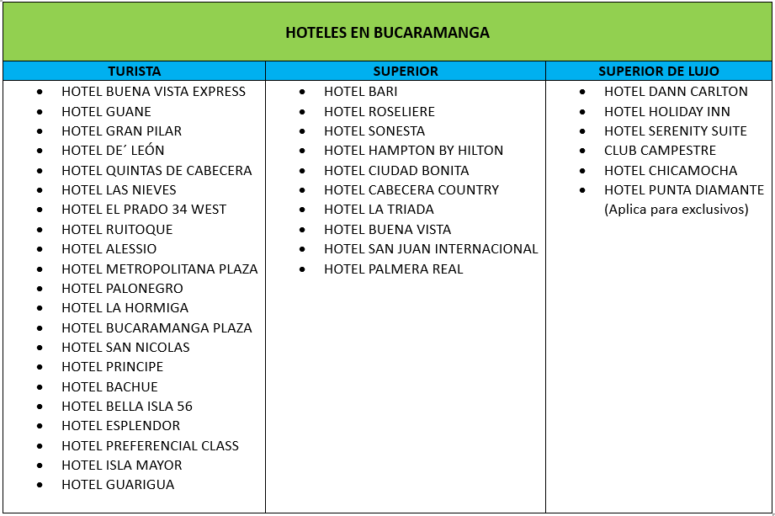**HOTELS**