**SAN GIL + PANACHI 1N/2D**

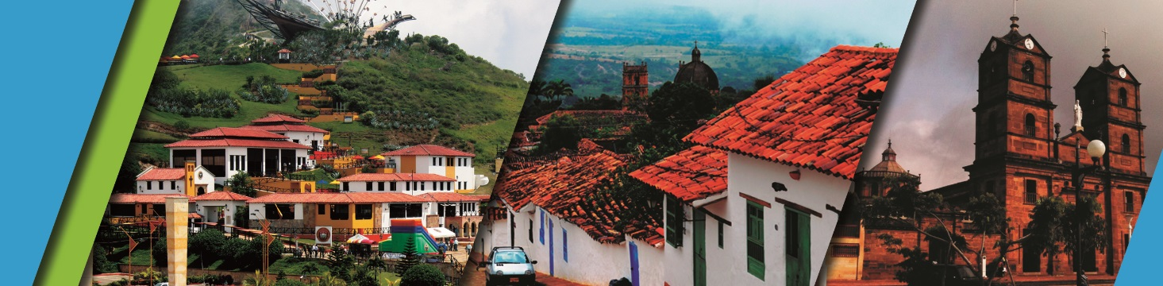

We invite you to discover Bucaramanga and Santander with the best plan:

**PLAN INCLUDES:**

* Transportation (AAA) during the tour, tour guide accompaniment, and medical assistance
* 1 night's accommodation in San Gil (Hotel Campestre)
* Taxes and hotel insurance
* Breakfast
* Lunch
* Dinner
* Tour Barichara
* Tour Gallineral in San Gil
* Tour Curití
* Tour Chicamocha National Park
* Transfer from Chicamocha National Park to San Gil by intercity bus

**NOT INCLUDED**

* Expenses not specified in the program

**ITINERARY**

**DAY 1**

* Departure at 7:30 a.m.
* Visit to the farmers' market
* Entrance to Chicamocha National Park.
* Tour of the 6.3 km second deepest canyon in South America.
* Transfer to San Gil by intercity bus
* Accommodation at the Cacique Yariguíes country hotel
* Dinner at the hotel

**DAY 2**

* Breakfast at the hotel
* Visit to Curití, land of fique weaving
* Visit and admission to Gallineral Natural Park
* Lunch
* Visit to Barichara, Colombia's most beautiful village, paper workshop, crafts workshop, and visit to the viewpoint and churches
* Return to Bucaramanga

|  |  |  |  |  |
| --- | --- | --- | --- | --- |
| **RATE PER PERSON** | | | | |
| **HOTEL** | **MULTIPLE** | **DOUBLE** | **SINGLE** | **CHILDREN (5 a 10)** |
| **TOURIST** | $169 | $182 | $190 | $145 |
|  |  |  |  |  |

**RECOMMENDATIONS DURING THE TOUR**

* To ensure you enjoy your experience to the fullest on this tour, we share the following recommendations:

* Bring sunscreen
* Bring a cap or hat
* Wear cool clothing and comfortable shoes
* Bring a swimsuit to enter the water park
* Bring a change of clothes for after rappel (additional cost)
* Driver's license to enter the buggies (additional cost)
* Camera
* Bring water
* To contribute to the conservation of the environment, we recommend depositing waste in a trash can

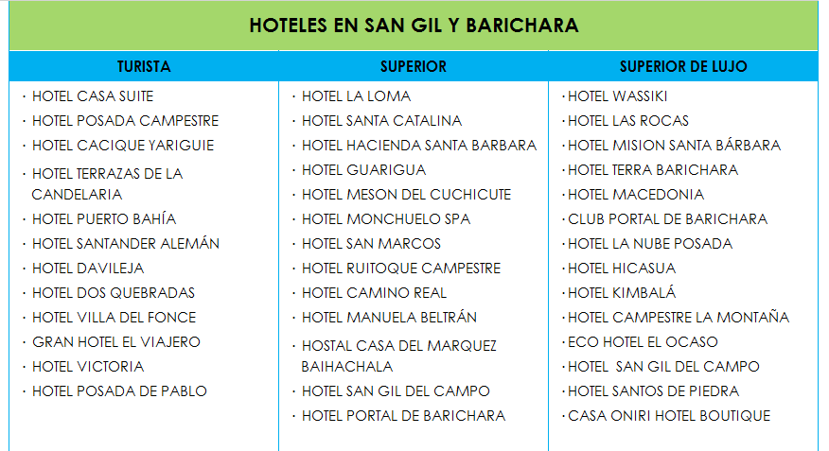**HOTELS**