**THE PORTAL 1N/2D**

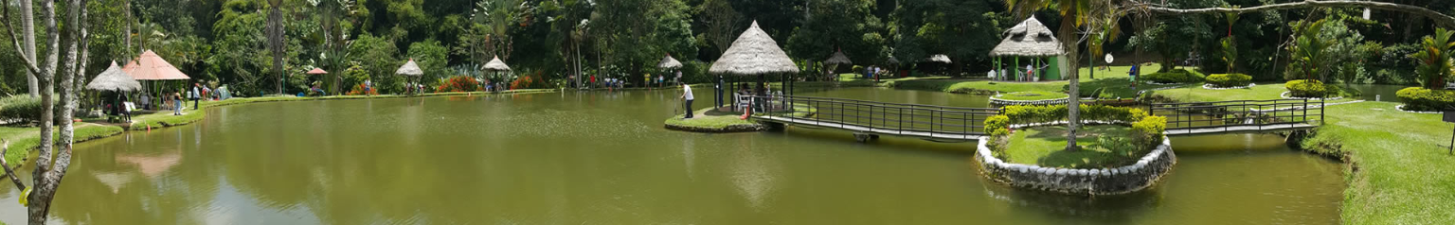

¡AN AMAZING PLACE!

**PLAN INCLUDES:**

* Hotel accommodation (1 night).
* Taxes and hotel insurance
* Medical assistance
* Transportation Bucaramanga-Ríonegro-Bucaramanga.
* Breakfast
* Dinner
* Lunch
* Access to and enjoyment of all facilities, including natural pools, waterfalls, fishing lakes, mountain biking, karaoke bar, natural wells, nature trails, and much more...
* Lunch at La Hacienda Restaurant: includes main course and beverage of your choice.
* Tour guide to provide orientation in the facilities.

**NOT INCLUDED**

* Expenses not specified in the program

|  |
| --- |
| **RATE PER PERSON** |
| **Triple Accommodation:** |
| **$106 dollars** |
|
|