**CLOSER TO THE SAINTS 1N/2D**

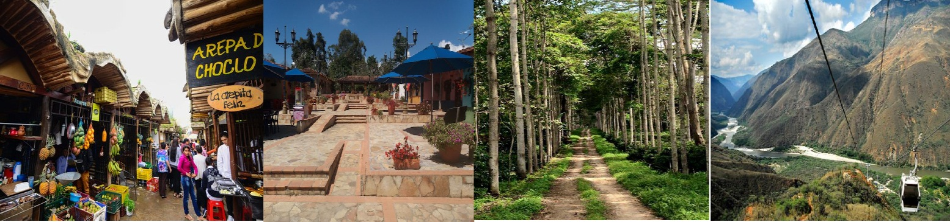

We invite you to discover Bucaramanga and Santander with the best plan

**PLAN INCLUDES:**

* Transfer from the airport to La Mesa de los Santos
* Permanent transportation
* Visit to the farmers' market
* Visit to Mi Colombia Querida
* Traditional lunch
* Visit to El Roble Hacienda
* Dinner
* Accommodation at Hotel Santa Clara
* Breakfast at the hotel
* Visit to Chicamocha Park, including entrance, cable car, and water park
* Lunch
* Canoeing in Cepita

**NOT INCLUDED**

* Expenses not specified in the program

|  |  |
| --- | --- |
| **RATE PER PERSON** | |
| **ACCOMMODATION** | **PRICE** |
| Simple Accommodation Double Accommodation | **$185**  **$140** |
|  |  |

**RATE VALID FOR A MINIMUM OF 10 PEOPLE**

**RECOMMENDATIONS DURING THE TOUR**

To ensure you enjoy your experience to the fullest on this tour, we would like to share the following recommendations with you:

* Bring sunscreen
* Bring a cap or hat
* Bring cool clothing and comfortable shoes
* Bring a swimsuit to enter the water park
* Bring a change of clothes for after canyoning (additional cost)
* Driver's license to enter the buggies (additional cost)
* Bring a camera
* Bring water
* To help preserve the environment, we recommend disposing of waste in a trash can.