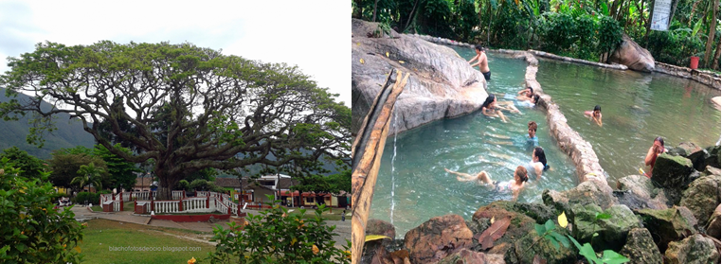

**THERMAL SPRINGS EL RAIZON 1N/2D**

Departure time: 4:00 a.m.

**PLAN INCLUDES:**

* Permanent transportation (AAA).
* Tour guide throughout the trip.
* Medical assistance cards for the trip.
* Accommodation in a hotel with multiple rooms.
* Meals: Breakfast, lunch, and dinner.

**Places to visit: El Raizon Hot Springs, Pamplona, Pamplonita, Bochalema Ecological Trail, Los 7 Chorros, Virgen de la Cueva Shrine, Pozo del Amor Waterfalls. (Entrance fees included).**

|  |
| --- |
| **RATE PER PERSON** |
|  |
| **$98 dollars** |
|
|

* Children aged 0-3 years only pay $30,000* for medical assistance.

*Double occupancy supplement $30,000 per person. *

*Single occupancy supplement per night $60,000 per person. *

*All services additional to accommodation will be operated directly by the agency. *

*Supplement for exclusive transportation for 1-4 people: $900,000*

*Rates subject to availability and change without prior notice. *

*All departures are regular (excursion type) *