**PASSING BY SANTANDER 2N/3D**

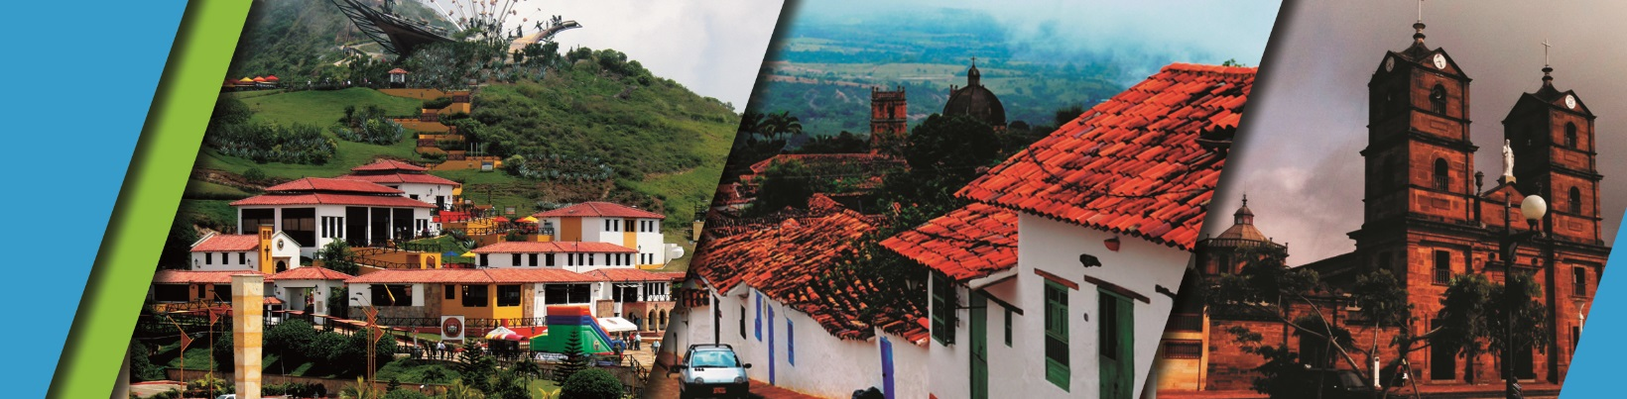

We invite you to discover Bucaramanga and Santander with the best plan:

**PLAN INCLUDES:**

* Accommodation at the hotel in Bucaramanga (2 nights)
* Taxes and hotel insurance
* Medical assistance
* Airport–hotel–airport transfer
* 2 breakfasts
* 2 lunches
* 2 dinners
* Tour crossing the Chicamocha (shared outing)
* City tour of Bucaramanga (shared outing)
* City night tour of Cerro del Santísimo (shared outing).
* Visit to the longest cable-stayed bridge

**NOT INCLUDED**

* Expenses not specified in the program

**ITINERARY**

**Day 1**

* Transfer Airport/Terminal – Hotel
* City Night Tour (Departure: 3:30 pm Hotel Lobby, Permanent Transportation, Tour Guide, Travel Insurance
* Visit to Girón (Heritage Town)
* Visit to Floridablanca, oblea Tasting, Entrance to Eco park, Cable Car Ride to Cerro El Santísimo, visit to the longest Cable-Stayed Bridge in Santander
* Dinner
* Accommodation in Bucaramanga

**Day 2**

* Breakfast at the hotel
* Tour Crossing the Chicamocha canyon (Meeting at 7:45 am Lobby del Hotel, visit to the Farmer’s Market at Mesa de los Santos, Snack - Entrance to PANACHI (Chicamocha National Park) by “Plazuela station”, Cable Car ride (6.3 km) where you can observe the wonderful canyon, a complete tour of the park facilities, admission to the water park.
* typical regional lunch.
* Return to Bucaramanga
* Dinner
* Accommodation in Bucaramanga.

**Day 3**

* Breakfast at the Hotel.
* City Tour (Departure: 8:30 a.m. Historical tour of the Beautiful City, entrance to the Cathedral “LA SAGRADA FAMILIA”
* visit to the city's first park “PARQUE CUSTODIO GARCÍA ROVIRA,” Panoramic tour of the government buildings “GOBERNACIÓN,” “ALCALDÍA,” and “PALACIO DE JUSTICIA.” This historical tour ends in San Francisco, the famous shoe district.
* Transfer from the Hotel to Aeropuerto Palo Negro
* End of our services.

|  |  |  |  |  |
| --- | --- | --- | --- | --- |
| **RATES PER PERSON** | | | | |
| **HOTEL** | **MULTIPLE** | **DOUBLE** | **SINGLE** | **CHILDREN (5 a 10 years old)** |
| **TOURIST** | $ 203 | $ 234 | $ 316 | $ 171 |
| **SUPERIOR** | $ 224 | $ 253 | $ 342 | $ 189 |
| **LUXURY SUPERIOR** | $ 258 | $ 308 | $ 453 | $ 216 |
|  |  |  |  |  |

|  |  |  |
| --- | --- | --- |
| **CHILDREN RATE** | | |
| **AGE** | **PRICE** | **INCLUDE** |
| **0 a 2** | $ 4 | Medical Assistance |
| **3 a 4** | $ 30 | Medical assistance, attraction tickets, and transportation |
|  |  |  |

* Dinner with a glass of wine applies to accommodation in the SUPERIOR AND SUPERIOR DELUXE categories.

*Exclusive transportation supplement for 1-4 people: $500,000*

*All departures are regular (excursion type).

*Children rate is NOT commissionable.

**RECOMMENDATIONS DURING THE TOUR**

To ensure you enjoy your experience to the fullest on this tour, we would like to share the following recommendations with you:

* Bring sunscreen
* Bring a cap or hat
* Bring cool clothing and comfortable shoes
* Bring a swimsuit to enter the water park
* Bring a change of clothes for after canyoning (additional cost)
* Driver's license to enter the buggies (additional cost)
* Bring a camera
* Bring water
* To help preserve the environment, we recommend disposing of waste in a trash can.

**HOTELS**

