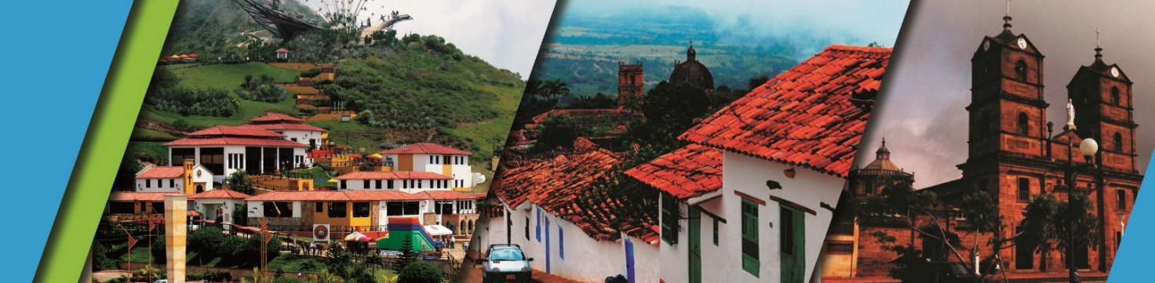

**PASSING BY SAN GIL 2N/3D**

We invite you to discover Bucaramanga and Santander with the best plan:

**PLAN INCLUDES:**

* Accommodation San Gil (2 nights)
* Taxes and hotel insurance
* Medical assistance
* Airport – Hotel – Airport transfer
* Breakfast
* Lunches
* Dinners
* Tour Crossing The Chicamocha Canyon
* Tour San Gil – Barichara - Curiti

**NOT INCLUDED**

* Expenses not specified in the program

|  |
| --- |
| **RATE PER PERSON** |
| **Double Accommodation:** |
| **$224**  **Hotel San Gil** |
|
|
| **$297**  **Alejandría Hotel Barichara** |

**ITINERARY**

**Day 1**

* Tour Crossing Chicamocha (Meeting at 7:30 a.m. - Hotel Lobby)
* Visit to the Farmers Market in Mesa de los Santos and small snack
* Entrance to Chicamocha National Park by “Plazuela” Station, total cable car-ride (6.3km) where you can observe the wonderful canyon, Total tour of the park facilities
* Transfer to San Gil
* Dinner
* Accommodation San Gil

**Day 2**

* Breakfast at the hotel
* Departure at 8:30 a.m.
* Sightseeing tour of SOCORRO
* Sightseeing tour of PINCHOTE (home of Antonia Santos - hereo of the Nation)
* Lunch
* Sightseeing tour of VALLE DE SAN JOSÉ
* Tasting of “CHORIZO DOÑA EUSTAQUIA”
* Dinner
* Accommodation in San Gil

**Day 3**

* Breakfast at the hotel
* Visit and tour of CURITI.
* Visit and entrance to EL GALLINERAL NATURAL PARK.
* Transfer to BARICHARA.
* Lunch in BARICHARA.
* Visit and sightseeing tour of BARICHARA and its churches.
* Return to Bucaramanga.
* End of our services.

**RECOMMENDATIONS DURING THE TOUR**

To ensure you enjoy your experience to the fullest on this tour, we share the following recommendations:

* Bring sunscreen
* Bring a cap or hat
* Wear cool clothing and comfortable shoes
* Bring a swimsuit to enter the water park
* Bring a change of clothes for after the zip-lining (additional cost).
* Driver's license to ride in the buggies (additional cost)
* Camera.
* Bring water
* To help preserve the environment, we recommend disposing of trash in a trash can

**HOTELS**

