**ORTICES LAGOON 1N/2D**

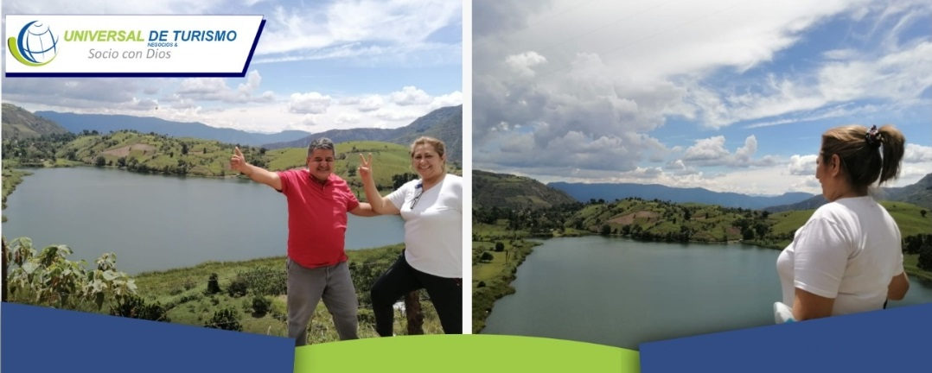

**We invite you to enjoy this wonderful trip with us**

**PLAN INCLUDES: Departure 5:30 am**

* 1night accommodation in San Andrés - Santander
* Permanent transportation (AAA)
* Tour guide throughout the tour
* Medical assistance
* Hotel tax and insurance
* Breakfast - Lunch - Dinner
* Tour of Santa Bárbara, Guaca, and San Andrés
* Boat trip on the Ortices Lagoon
* Visit to the San Andrés waterfall
* Walk across the Hisgaura bridge
* Optional: Visit to the Panela Route

**NOT INCLUDED**: Expenses not specified in the program

|  |  |  |  |
| --- | --- | --- | --- |
| **RATE PER PERSON** | | | |
| **HOTEL** | **MULTIPLE** | **DOUBLE** | **SINGLE** |
| Located | $93 | $100 | $116 |
|  |  |  |  |
| **CHILDREN RATE** | | | |
| **0-2 years old** | **3-4 years old** | | **5-10 years old** |
| $4  Medical Assistance | $50  Med Assis. - Entrance Attractions Transportation | | $76  Med Asis. - Entrance Attractions Transportation |
|  |  |  |  |

**Rates subject to availability and change without notice.**