**Hot Air Balloon flight 1N/2D**

FROM CHARALÁ: HOT AIR BALLOON FLIGHTS AND NEUGATAS

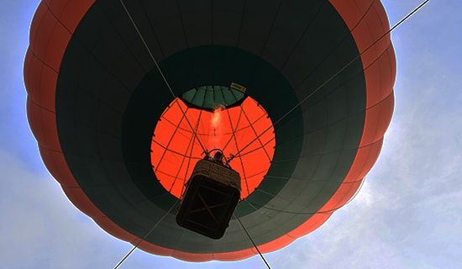

**We invite you to enjoy this wonderful experience with us.**

* 1 night's accommodation (shared room).
* Tour guide throughout the tour and travel insurance.
* Transportation to San Gil; transportation to Charala and back is by intercity bus (groups of less than 6 people).
* Private transportation (groups of more than 6 people).
* Breakfast.
* Lunch.
* Snack.
* Hot air balloon experience
* Ecological hike to Cueva el Cacique.
* Neugatas or tubing (river descent on inner tubes), swimming in a natural pool on the Taquiza River.
* Tour of the Historic and Cultural Center of Charalá.

**NOT INCLUDED:**

* Expenses not specified in the program
* Double occupancy supplement: $8

|  |
| --- |
| **RATE PER PERSON** |
| **Triple Accommodation:** |
| **$145** |
|
|

**ITINERARY**

**Departure time: 5:00 AM**

**Meeting point: Charalá Main Park**

**Day 1**

CHECK-IN 3 PM Selected hotel in Charalá.

**Day 2**

* 5:30 a.m.- 6:00 a.m. Logistics: Inflation, trimming, anchoring, and lifting the balloon for the first time. (Height 100 meters, each flight carries 3 people, average total weight 180 kg - 190 kg, average flight duration 7 minutes).
* 8:30 a.m. Breakfast.
* 9:30 a.m. Start of activities.
* Ecological Trail: Native forests, demonstration cattle farm (pastures, hedgerows).
* Ecological walk to Cueva el Cacique.
* Swimming in a natural pool in the Taquiza and Neugatas Rivers or tubing (floating down the river on a tire).
* Lunch in the Historic Center.
* Walk through the Historic and Cultural Center of Charalá

**RECOMENDATIONS:**

* Eco-friendly sunscreen and insect repellent.
* Personal towel for use during hikes.
* Small backpack for use during hikes.
* Sneakers or lace-up shoes.
* Shorts.
* Long-sleeved shirt or sweater.
* Cap.
* Personal first aid kit for allergies or special medications.
* Coat.

**IMPORTANT:**

* Maximum capacity: 20 people.
* All participants in the scheduled activities do so of their own free will and are responsible for their own actions.
* Price for balloon activity only: $200,000 (COP).
* Does not include transportation to the municipality of Charalá.