**SAN VICENTE DE CHUCURI**

**BIRDWATCHING DESTINATION IN COLOMBIA**

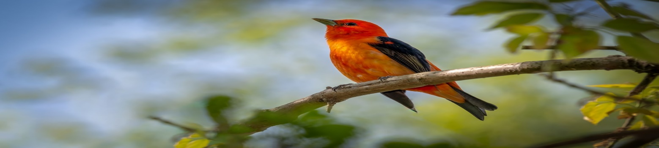

It is the world's leading country in terms of bird diversity (1,900 species, equivalent to 20% of the birds on Earth). There are 197 species of migratory birds, 193 near-endemic species, and 79 endemic species, with more than 365 species recorded in San Vicente de Chucuri. This makes it a unique destination in the world.

**BIOLOGICAL IMPORTANCE**

Among the birds recorded in the area are the Santanderean Partridge (Odontophorus strophium), the Black Inca (Coeligena prunellei), the Chestnut-bellied Hummingbird (Amazilia castaneiventris), the White-backed Torito (Capito hypoleucus), Parker's Antbird (Cercomacra parkeri), the Mouse Tapaculo (Scytalopus latebricola), the Mountain Thrush (Macroagelaius subalaris), and the Axe-billed Antbird (Clytoctantes alixii). It is also possible to see amphibians such as the Poison Dart Frog (Myniobates virolinensis) and mammals such as the Spectacled Bear (Tremarctos ornatus).

**The customer is guided throughout the trip by local guides.**

**CHARACTERISTICS OF THE SITES TO BE VISITED**

* Diversity of habitats and landscapes
* High number of bird species
* Endemic birds
* Presence of migratory birds
* Safety, Food, insurance, typical meals, quality of local transportation
* Quality of accommodation.

The estimated duration of the experience is approximately 6-8 hours.

Suggested start time for the activity between 5:30 a.m. and 6 a.m.

**ITINERARY**

* Reception at Quita Tibi Garo Hotel (afternoon)
* Visit to historical museum house (depending on arrival time)
* Breakfast.
* Daily departures between 5:00 a.m. and 6:00 a.m.
* Arrival at the site.
* Introduction to the local guide.
* Ground transportation.
* Eight-hour tour.
* End of activity.

**IMPORTANT**

* Wear comfortable clothing
* Preferably two pairs of closed-toe athletic shoes and sunscreen
* Hat
* Mosquito repellent
* Sunglasses
* Identification documents.
* Hydration: a bottle of water
* Yellow fever vaccination
* Bird watching equipment

**ENVIRONMENTAL RECOMMENDATIONS AND RESTRICTIONS**

* Stay on marked trails to avoid damaging vegetation and wildlife.
* Do not litter on trails or in other areas frequented by visitors.
* Do not leave anything behind in the area; take everything back with you in your backpack and dispose of it in designated community areas.
* Refrain from collecting any type of plant or animal material. Do not pick or pinch leaves, flowers, branches, or fruit.
* Do not build fires, even for recreational purposes, as they could cause fires.
* Alcoholic beverages and/or hallucinogens are prohibited.
* Entering the area while intoxicated is prohibited.
* If you have any questions or concerns, please consult your guide.
* Be cordial and respectful to the farmers. Remember that we are visiting “their home.”
* Be supportive, respectful, a good companion, and always maintain unity with the group.
* It is mandatory to fill out the form informing you of the restrictions and recommendations.
* You must sign it before entering the attraction.

**PLAN INCLUDES**

* Accommodation at Quinta Tibi Garo Hotel.
* Breakfast.
* Lunch.
* Hydrating drinks.
* Identification.
* Local guides. Insurance.
* Transportation from the hotel to Serranía de los Yariguíes Park.

**NOT INCLUDED:** Information not specified in the plan. Guides with proficiency in English or translator.

|  |
| --- |
| RATE PER PERSON |
| **FROM** |
| **$185 dollars** |
| WITH TRANSPORTATION BY HORSE $211 dollars |

**Rates subject to availability and change without notice**